After you have studied fully the Scoreboarding technique, we shall proceed forward.

We have seen that Scoreboard is very fast. But it has a disadvantage, it does not have DATA FORWARDING as we had seen earlier.

If scoreboard + Data forwarding is there, we can be still faster. Tomasulo algo is having forwarding capacity and is hence still faster than scoreboaring.

Listen the following videos from Prof John Jose of IITG. First type Adv Computer Architecture in youtube, you will get a set of 34 videos, now search for 12th lecture from the series, namely,

# Lec 9: Dynamic Scheduling with Tomasulo’s Algorithm

# (<https://www.youtube.com/watch?v=Aj5cA3qBxrQ&list=PLwdnzlV3ogoWJhBxBYu-K4l-q-nNHd24D&index=12>)

The quality of the picture is important when he would explain with a diagram. Improve quality of picture by clicking on the settings of the video itself.

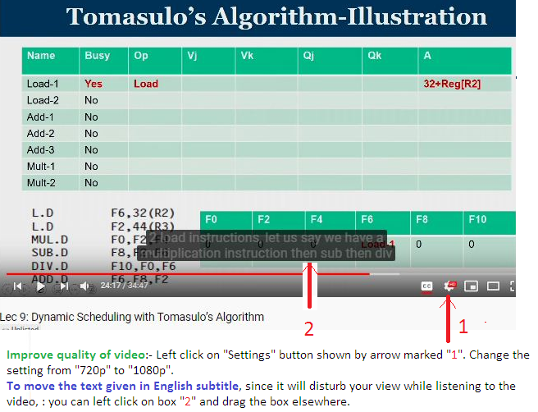

# You can also view the following 14.48 minute video as shown below:

# Tomasulo's Algorithm Overview

# (<https://www.youtube.com/watch?v=jyjE6NHtkiA>)

# This however does not show RSI (Register Status Indicator) which can be compared to “Functional Unit Status” of Scoreboarding which helps in checking Structural Hazard before an instruction is issued.

# Also

# Tomasulo Algorithm

# (<https://www.youtube.com/watch?v=CoaXXZjSqHE>)

This lecture is showing how the prog is executed in each cycle just like Scoreboard we did in class. It also shows RSI.

**Reservation stations (RS):** These are queues one in front of each hardware unit. There may be two adder unit, 3 multiplier unit and so on. The is a store and a load unit. In front of each of the unit there will be a queue and called reservation station. Say there is a store unit to store data in mem. You need two parameters to store in mem viz Mem location and the data to be written.

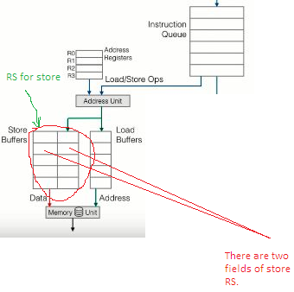

What is reservation station of Multiplier and Adder Unit:-

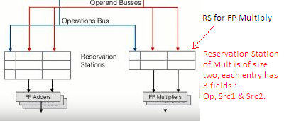

CDB: There is a CDB (Common Data Bus) through which any hardware unit’s result goes to reach the destination like Register file (in case of Read Operation etc), to memory (in case of Store operation),